

**Data Technician**

|  |
| --- |
|  |

|  |
| --- |
| Name: Danny O’Keefe. |
| Course Date: |
|  |

**Table of contents**

Day 2: Task 1 3

Day 2: Task 2 4

Day 2: Task 3 5

Day 3: Task 1 6

Day 3: Task 2 7

**Dataset:** 7

**Step 1: Create a Pivot Table** 7

**Step 2: Use the SWITCH Function** 7

**Submission:** 8

Day 3: Task 3 9

**Course Notes** 10

**Additional Information** 11

# Day 2: Task 1

Please research and complete the following tasks within the retail-sales_dataset.xlsx document, paste a print screen into the provided boxes below:

1. Using the ‘filter’ function, filter ‘Age’ to ‘largest to smallest’
2. Using the ‘SUM’ function, show me the commission total in cell ‘**P10’**
3. Using the ‘AVERAGE’ function, show me the average commission in cell **‘P11’**

|  |  |
| --- | --- |
| Print screen 1 |  |
| Print screen 2 | Font changed to blue colour for reference. |
| Print screen 3 | Font changed to colour blue for reference. |

# Day 2: Task 2

Please research and complete the following tasks within the retail-sales_dataset.xlsx document, paste print screens into the provided box below:

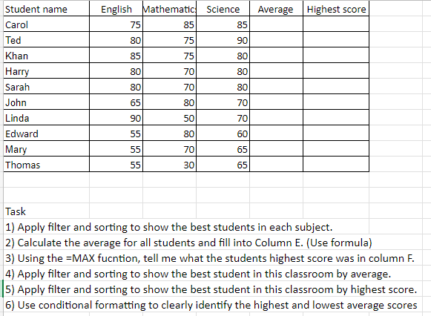

|  |  |
| --- | --- |
| Print screen 1 | English best student. Maths best student. Science best student.    Average student scores. Max student scores. Best student by average.    Best student by highest score. Conditional Formatted data. |
|  |  |

# Day 2: Task 3

Using the skills developed today, have some fun with the data set you have imported. Paste your work below and enjoy!

|  |  |
| --- | --- |
| Print screen 1 | Finding out how to find the total sales and commissions by using multiplication and cell locking. |
| Print screen 2 | Learning about Unique average and averageif formulas. |
| Print screen 3 | Learning about day, month and year formulas. |
| Print screen 4 | Task 2 works completed today, finding out about average and max values, and conditional formatting. |

# Day 3: Task 1

Please download the dataset ‘Day_3_Task_1_Bike_Sales_Pivot_Lab.xlsx’ from [here](https://justit831-my.sharepoint.com/:x:/g/personal/danpe_justit_co_uk/Eb73L6LixCJHtafDJ4AOh-ABR9CVF0n9sdEgB4foSh261g?e=jh493A).

The lab instructions can be found [here](https://justit831-my.sharepoint.com/:b:/g/personal/danpe_justit_co_uk/EVySAtWQiEVDmrtCufrqTgwBuLVxX6mEKYqEAe0Mgl6b9Q?e=i05yOa). Do not worry if you do not complete the lab, just working with data and playing with the pivot table will be good experience.

Please paste your final pivot table below and complete the reflection questions:

|  |  |
| --- | --- |
| Print screen 1 | (Multiple United States – please see ‘Any other findings’ for more information. |
| In which markets does Germany have customers? | Germany has markets in both Male and Female Adults. |
| What country has sales in all markets? | There are 2 countries with sales in all markets, they are Australia and UK. |
| What are the most profitable markets by country, age group, and gender? | Young female adults in Australia and female adults in united states are most profitable locations. |
| Any other findings? | I’ll be honest, I totally missed the 3 columns of United States, so I made sure to check all spellings on the datasheet, and this fixed the 3 separate boxes and combined the boxes to one column. To do this I used the =Trim and =Upper functions to trim any extra spaces in the spellings and upper to make sure all had upper case where needed. |

# Day 3: Task 2

The dataset below tracks the sales performance of different products in various counties in England. Please paste the dataset into a blank Excel workbook. Your task is to:

* **Create a Pivot Table** to summarise the data by county and product.
* **Use the SWITCH function** to categorise products based on their sales volume.

#### **Dataset:**

|  |  |  |
| --- | --- | --- |
| **County** | **Product** | **Sales Volume** |
| Yorkshire | Laptops | 500 |
| Yorkshire | Smartphones | 200 |
| Cornwall | Laptops | 700 |
| Cornwall | Printers | 400 |
| Lancashire | Smartphones | 150 |
| Lancashire | Laptops | 600 |
| Essex | Printers | 800 |
| Essex | Smartphones | 300 |
| Durham | Laptops | 250 |
| Durham | Printers | 300 |
| Greater Manchester | Smartphones | 600 |
| Greater Manchester | Laptops | 400 |

#### **Step 1: Create a Pivot Table**

* Select the dataset (columns A to C).
* Insert a Pivot Table to summarise the data by **County** in the rows and **Products** in the columns. Use **Sales Volume** as the value to be summarised.

#### **Step 2: Use the SWITCH Function**

In a new column next to your data, use the SWITCH function to categorise products based on **Sales Volume** as follows:

* + For sales greater than 600: **"High"**
  + For sales between 300 and 600: **"Medium"**
  + For sales less than 300: **"Low"**

**SWITCH Function Example**:

=SWITCH(TRUE, C2 > 600, "High", C2 >= 300, "Medium", "Low")

* Apply this formula to each row, and check if the products are categorised correctly.

#### **Submission:**

* A completed Pivot Table summarising sales by county and product.
* A new column in the dataset categorising products by sales volume using the SWITCH function.
  + Please paste your completed work below

|  |  |
| --- | --- |
| Print screen 1 |  |

# Day 3: Task 3

Please download the dataset ‘Day_3_Task_3_Bike_Sales_Visualisations_Lab.xlsx’ from [here](https://justit831-my.sharepoint.com/:x:/g/personal/danpe_justit_co_uk/ESeJLtyZhYxIpZXluVywvvkBxgx2EtpPUzmxLCzQBGTKNQ?e=naSu4B).

The lab instructions can be found [here.](https://justit831-my.sharepoint.com/:b:/g/personal/danpe_justit_co_uk/Ec1IWsNPl_ZMuaSbNcaLyVcByy3JcZaQgoG1FeFwO9neRQ?e=6lsJG1) Do not worry if you do not complete the lab, just working with data and playing with the charts will be good experience.

Please paste your results below:

|  |  |
| --- | --- |
| Print screen 1 | Pie Chart.    Stacked Column Chart.    Line Graph. |

|  |
| --- |
| **Course Notes** |

It is recommended to take notes from the course, use the space below to do so, or use the revision guide shared with the class:

|  |
| --- |
|  |

|  |
| --- |
| **Additional Information** |

We have included a range of additional links to further resources and information that you may find useful, these can be found within your revision guide.

**END OF WORKBOOK**

**Please check through your work thoroughly before submitting and update the table of contents if required.**

**Please send your completed work booklet to your trainer by submitting in MS Teams Assignment page.**